HUMAN-COMPUTER INTERACTION (HCI) • TAB 4: COMPLETE CONSOLIDATED DOCUMENT
ISO 9241-210 Human-Centered Design Evaluation of the Enhanced Tax Revenue Assessment and Collection System (ETRACS)
A Comparative Reference Evaluation for the Proposed Real Property Assessment Tracking and Inter-Office Synchronization System
Authors / Group: | Group 23 • Christian Louise O. Asido, John Kenneth P. Calubad, Rizalina A. Ortega
Institution / Term: | School of Computer and Information Sciences, University of Nueva Caceres • AY 2026–2027

A. System Overview
The Enhanced Tax Revenue Assessment and Collection System (ETRACS) is an enterprise software platform developed by Rameses Systems Incorporated in Cebu City, Philippines. The system runs on the proprietary Osiris 2 enterprise framework. It utilizes a Service-Oriented Architecture (SOA), a Java Swing desktop fat-client runtime, and relational database management systems such as MySQL and Microsoft SQL Server. Local Government Units (LGUs) deploy ETRACS to automate real property assessment, business tax licensing, treasury collections, and accountable forms inventory.
The primary objective of ETRACS is to automate municipal revenue administration under Republic Act Number 7160 (The Local Government Code of 1991). The platform provides modular sub-systems for Real Property Assessment (RPT), Land Tax Billing, Treasury Collections, and Accountable Form Management. In the RPT module, tax mappers and municipal assessors record Field Appraisal and Assessment Sheets (FAAS) for land, building, and machinery units. The software automatically applies statutory assessment levels, schedules of market values, and computes assessed property values. It generates computerized Tax Declarations (TD) and links newly assessed parcels directly to municipal treasury cashiering ledgers.
ETRACS directly connects to the proposed system as a benchmark reference. The platform proves that linking municipal assessor valuation records to treasury collection ledgers prevents duplicate billing and manual reconciliation errors. However, field implementation reveals severe technical and operational boundaries. ETRACS operates as an installed desktop fat-client that requires dedicated on-premises servers and workstation configurations. These installation requirements create heavy maintenance barriers for resource-constrained fourth-class municipalities. In addition, ETRACS contains no document tracking engine to trace physical paperwork routed to external provincial offices, such as the Provincial Capitol in Pili. Property owners receive no transaction visibility during assessment transfers. The proposed system directly resolves these operational boundaries by implementing a lightweight three-tier web architecture with automated document routing and real-time transaction tracking.
B. Identified Users and Context of Use
Human-Centered Design requires an explicit understanding of user groups, tasks, tools, and environments under ISO 9241-210 Clause 6.2. Field studies and public documentation identify distinct user groups and environmental conditions for municipal property taxation:
1. Primary User Groups
- Municipal Assessor Staff (Tax Mappers, Appraisers, Municipal Assessor): Staff capture parcel boundaries, encode FAAS records, calculate market and assessed values, issue certified Tax Declarations, and approve subdivisions or title transfers. They interact with dense tabular data forms, coordinate with provincial authorities, and maintain municipal tax rolls.
- Municipal Treasurer Staff (Revenue Clerks, Cashiers, Liquidators): Cashiers query property tax liabilities using Property Index Numbers (PIN) or Tax Declaration numbers, collect cash payments, issue official receipts (Form 56), track accountable receipt inventories, perform daily remittances, and reconcile collection ledgers.
- Local IT and MIS Officers: System administrators manage user role permissions, configure local tax ordinance rate schedules, execute local database backups, and troubleshoot client terminal network connections.
2. Secondary User Groups
- Property Owners and Taxpayers: Citizens visit municipal counters to verify property tax liabilities, settle annual taxes, request certified true copies of tax declarations, and process assessment transfers. They interact with counter staff and experience queue delays.
- Provincial Assessor Reviewers: Provincial assessment officers at the Capitol review municipal appraisal rolls, endorse new building assessments, and approve general property revisions under statutory oversight rules.
3. Context of Use, Hardware, and Environmental Conditions
Personnel operate the software inside municipal halls during government business hours (8:00 AM to 5:00 PM, Monday through Friday). Transaction loads fluctuate sharply. Routine days involve 50 to 100 transactions, while tax discount deadlines in January and quarterly payment cutoffs create heavy counter congestion.
The operational environment introduces substantial physical and infrastructural constraints:
- Hardware and Terminals: Personnel use aging desktop personal computers running Windows operating systems with Java Runtime Environment (JRE). Cashiers rely on dedicated dot-matrix impact printers to print multi-copy accountable paper forms (Official Receipt Form 56).
- Local Network Infrastructure: Workstations communicate across local area network (LAN) connections to an on-premises local server. Internet connectivity in rural municipalities is unstable, preventing continuous cloud synchronization.
- Physical Office Environment: Service counters face high ambient noise, crowded citizen queues, and warm temperatures during peak payment months. Electrical power interruptions occur frequently, creating risks of dropped client sessions.
- Legacy Document Handling: Staff must manually consult historical paper ledgers dating back to 1949 stored on open wooden shelves while simultaneously operating desktop input screens.
C. Usability Strengths and Issues
Evaluating ETRACS from human factors and interaction ergonomics reveals distinct technical accomplishments alongside critical usability bottlenecks:
1. Usability Strengths
- High Task-Domain Fidelity: The desktop screens mirror official statutory forms, including the Field Appraisal and Assessment Sheet (FAAS) and Tax Declaration Form. Clerks familiar with paper procedures recognize field labels without extensive conceptual retraining.
- Automated Statutory Calculations: The system automatically applies assessment levels, basic real property taxes, Special Education Fund (SEF) levies, prompt-payment discounts (10% to 20%), and statutory monthly delinquency penalties (2% per month). This automation eliminates manual arithmetic errors.
- Financial Integrity and Accountable Forms Control: The software strictly tracks official receipt serial numbers, blocks duplicate numbers, and enforces sequential cashiering reconciliation. This control meets Commission on Audit (COA) requirements.
- Granular Role-Based Permissions: The application enforces strict separation of duties between assessor appraisal encoding and treasurer cashiering. This access control prevents unauthorized valuation changes during payment collection.
2. Usability Issues and Pain Points
- High Visual Density and Cognitive Fatigue: Screen layouts display crowded data tables, multi-tab dialogs, and dozens of simultaneous entry fields without progressive disclosure. Navigating dense nested grids induces eye strain and operator errors during high-volume counter operations.
- Desktop Fat-Client Maintenance Overhead: The Java Swing desktop client requires manual installation and local configuration on every workstation. Operating system updates, Java runtime mismatches, and database client conflicts require on-site technical support that rural LGUs cannot easily provide.
- Complete Lack of Inter-Office Workflow Tracking: ETRACS updates internal database states but provides no tracking monitor for physical document routing. When property transfers require external endorsement from the Provincial Capitol in Pili, the system offers no queue monitor or milestone tracking. Citizens and staff experience 7 to 14 days of unmonitored delays.
- Steep Learning Curve and Cryptic Feedback: The user interface relies heavily on technical acronyms, statutory codes, and complex shortcut combinations. Error messages frequently expose raw database exception strings rather than actionable user instructions.
- Absence of Accessibility and Individualization Accommodations: Fixed font sizes, rigid window dimensions, low visual contrast in dense tables, and lack of screen scaling impede operators with visual or physical fatigue.
- Severe Legacy Migration Overhead: The strict database schema rejects incomplete records. Migrating decades-old manual paper records dating back to 1949 requires intensive manual cleansing, creating large encoding backlogs.
D. Evaluation Using ISO 9241-210 Framework
The ISO 9241-210:2010 standard defines requirements and recommendations for human-centered design throughout interactive system life cycles. Table B.1 in Annex B provides the official checklist to assess compliance. ETRACS was evaluated against this checklist using published research, technical documentation, and observable interface screens.
Synthesis of Human-Centered Design Conformance
ETRACS presents a strong operational paradox: it achieves high domain effectiveness for statutory accounting compliance while failing formal human-centered design conformance across multiple life cycle dimensions. The software was engineered from an accounting and database-centric perspective rather than a user-centered design paradigm.
Under Clause 4 (Principles of Human-Centered Design), ETRACS partially satisfies principle 4.2 by defining direct user roles for municipal assessors and cashiers. The system also satisfies principle 4.6 by aligning automated tasks with statutory municipal job functions. However, the system fails principles 4.3 and 4.4. Development was consultant-driven and engineering-led without active participatory design or user-centered formative evaluations. Iteration across software releases (principle 4.5) addressed legal mandates, business taxes, and electronic payment integrations rather than usability improvements. Public documentation records no usability testing, think-aloud studies, or standardized satisfaction surveys.
Under Clause 5 (Planning Human-Centered Design), ETRACS conforms poorly. Rameses Systems integrated systems engineering and public finance expertise but did not formally allocate project time or resources to human factors activities. Project plans focused on database consistency, network security, and statutory rule validation. No procedures were established to evaluate usability risks or balance human-system trade-offs.
Under Clause 6 (Human-Centered Design Activities), the system achieves mixed results. For Context of Use (Clause 6.2), technical hardware environments and organizational roles are thoroughly defined. However, user characteristics, cognitive workloads, and physical environmental constraints were largely ignored. For User Requirements (Clause 6.3), functional requirements derived from Republic Act 7160 are explicitly stated, but measurable usability criteria (such as task completion time or error rate thresholds) are absent.
For Design Solutions (Clause 6.4), ETRACS aligns well with task suitability under ISO 9241-110 dialogue principles by automating complex land tax computations. However, it fails self-descriptiveness, suitability for learning, and suitability for individualization. Screen layouts pack multiple complex sub-tables into fixed windows without inline explanations. Finally, for Design Evaluation (Clause 6.5), ETRACS demonstrates a major conformance gap. System acceptance in adopting LGUs relies entirely on financial balance reconciliations and database transactional audits. No empirical usability evaluations or long-term human performance monitoring were conducted.
E. Recommendations for Improvement and Connection to the Proposed System
Based on the ISO 9241-210 checklist findings and usability analysis, five concrete design recommendations are established for ETRACS. Each recommendation directly informs the architectural and interaction design of the proposed system:
- 1. Transition to a Zero-Client Three-Tier Web Architecture: ETRACS relies on an installed Java Swing desktop client that burdens municipal workstations. Recommendation: Migrate the presentation layer to modern browser standards (HTML5/CSS3/JavaScript). Lesson Applied to the Proposed System: The proposed system adopts a three-tier web architecture with a browser-accessible presentation tier. This design requires zero local software installation and runs smoothly on standard municipal office desktop workstations.
- 2. Integrate an Automated Document Routing and Milestone Tracking Module: ETRACS lacks multi-office workflow tracking, causing 7-to-14-day delays during property transfers. Recommendation: Build an automated state machine that logs document transfers with real-time timestamps. Lesson Applied to the Proposed System: The proposed system engineers an Assessment Request Routing Module with an Administrative Workflow Panel. This module tracks transactions between the Assessor, the Treasurer, and the Provincial Capitol in Pili, eliminating manual paper tracking slips.
- 3. Apply Progressive Disclosure and Form Chunking: ETRACS displays dozens of input fields on crowded multi-tab screens, causing operator fatigue. Recommendation: Divide lengthy appraisal and assessment forms into sequential, logical steps with inline validation. Lesson Applied to the Proposed System: The proposed system implements step-by-step appraisal screens with clear tooltips and validation alerts to reduce operator cognitive load.
- 4. Deploy Role-Tailored Operational Dashboards: ETRACS bundles appraisal, cashiering, and business permit functions into complex menus. Recommendation: Provide clean, dedicated operational interfaces for specific departmental roles. Lesson Applied to the Proposed System: The proposed system delivers role-segregated screens: an appraisal evaluation dashboard for assessors and a tax payment validation interface for treasurers.
- 5. Institutionalize Formative Usability Testing under ISO/IEC 25010: ETRACS omitted user-centered usability testing during development. Recommendation: Integrate usability evaluations with representative municipal clerks throughout development sprints. Lesson Applied to the Proposed System: The proposed system integrates two-week Agile development sprints with iterative ISO/IEC 25010 evaluations, measuring functional suitability, usability, and performance efficiency directly with municipal staff in Pasacao, Canaman, Magarao, and San Fernando.

--- PART II: COMPLETED ISO 9241-210:2010 CONFORMANCE CHECKLIST ---
Attachment: Completed ISO 9241-210:2010 Conformance Checklist (Table B.1)
This checklist evaluates ETRACS against the official ISO 9241-210:2010 Annex B Table B.1 standard. In accordance with strict evaluation protocol, requirements and recommendations lacking verifiable public documentation or published empirical records are marked 'No' in conformance, with explanatory analysis provided in the comments.
Clause | Requirement / Recommendation | Applicable (Y/N) | Reason N/A | Met Y | Met N | Evaluation Comments & Evidence
4.1 | Human-centred approach follows principles in 4.1 | Y |  |  | N | Architecture prioritized statutory accounting rules and database consistency over human-centred design processes.
4.2 | Design takes account of people using system and affected stakeholders | Y |  | Y |  | Identifies direct municipal assessor and treasurer staff; secondary taxpayers have limited direct system affordances.
4.2 | All relevant user and stakeholder groups identified [see 6.2.2 a)] | Y |  | Y |  | Formal user roles exist for Appraiser, Tax Mapper, Municipal Assessor, Cashier, and Treasury Liquidator.
4.3 | User involvement is active | Y |  |  | N | Public records indicate top-down consultant deployment without evidence of active participatory user design sessions.
4.3 | Users involved reflect capabilities, characteristics, and experience [6.2.2 b)] | Y |  |  | N | System assumes highly trained operators; does not account for varied digital literacy across lower-class municipal staff.
4.4 | User-centred evaluation takes place as part of final product acceptance | Y |  |  | N | Acceptance in adopting LGUs is based on financial balance audits and statutory rule compliance, not usability testing.
4.5 | Iteration used to progressively eliminate uncertainty during development | Y |  | Y |  | Rameses released iterative updates across software versions (v2.0 to v2.5) to expand business tax and e-payment support.
4.6 | User experience of previous systems and branding considered | Y |  | Y |  | Screen fields directly replicate manual paper forms (FAAS and Tax Declarations), preserving familiar mental models.
4.6 | Users' strengths, limitations, preferences, and expectations considered in function allocation | Y |  |  | N | Heavy manual data entry is allocated to clerks without automated validation aids or modern OCR document ingestion.
4.6 | Representative users involved in decisions on allocation of function | Y |  |  | N | No public records demonstrate end-user participation in allocating automated versus manual system tasks.
4.6 | Human activities resulting from function allocation form a meaningful set of tasks | Y |  | Y |  | Clerks complete cohesive workflows for property valuation revisions, tax declarations, and official receipt issuance.
4.7 | Human-centred design team includes multidisciplinary skills and perspectives | Y |  |  | N | Development team comprised software engineers and public finance specialists; UX and ergonomics experts were omitted.
5.1 | Human-centred design planned and integrated into all life cycle phases | Y |  |  | N | No public documentation indicates formal human-centred design integration during software conception or engineering.
5.2 a) | Evaluate how usability relates to purpose and use of product | Y |  |  | N | Project scope focused on statutory compliance with RA 7160 rather than formal usability relationship evaluations.
5.2 b) | Evaluate levels of risk resulting from poor usability | Y |  |  | N | Poor usability resulted in documented training bottlenecks and slow adoption in rural LGUs (Chinilla & Lagura, 2025).
5.2 c) | Evaluate nature of development environment | Y |  |  | N | Desktop client-server architecture was selected for local data sovereignty rather than user accessibility convenience.
5.3 a) | Identify appropriate HCD methods and resources for Clause 6 activities | Y |  |  | N | No published records show allocation of human-centred research methods or usability testing resources.
5.3 b) | Define procedures for integrating HCD activities with system development | Y |  |  | N | Development followed traditional engineering milestones focusing on database schema design and service APIs.
5.3 c) | Identify individuals/organizations responsible for HCD activities and skills | Y |  |  | N | Roles were assigned for software engineering, database administration, and tax law consulting, omitting HCD leads.
5.3 d) | Develop feedback and communication procedures on HCD and trade-offs | Y |  |  | N | No structured communication channels for ergonomic or usability trade-off documentation are publicly recorded.
5.3 e) | Agree on appropriate milestones for HCD integrated into schedule | Y |  |  | N | Milestones focused on functional module delivery, accounting validation, and LGU live rollout dates.
5.3 f) | Agree on suitable timescales for iteration and incorporating user feedback | Y |  |  | N | Schedule allocated time for legal policy updates and bug fixes, with no dedicated usability iteration cycles.
5.4 | HCD plan forms part of overall system development project plan | Y |  |  | N | Public project documentation reflects technical software architecture and deployment guides without an HCD plan.
5.4 | HCD plan subject to same project disciplines as other key activities | Y |  |  | N | No formal HCD tracking or change control records exist in public documentation repositories.
5.4 | HCD aspects of project plan reviewed and revised as requirements change | Y |  |  | N | Requirements revisions were driven by legislative changes and LGU executive requests, not HCD reviews.
5.5 | Project planning allocates time and resources to HCD activities | Y |  |  | N | Resources were allocated to developer coding, database migration, and staff training, omitting HCD activities.
5.5 | Plan includes time for iteration and user feedback on user requirements | Y |  |  | N | Feedback was captured through user bug reports and helpdesk tickets during post-deployment operations.
5.5 | Additional time allocated to communication among design team on trade-offs | Y |  |  | N | No evidence of documented trade-off discussions addressing operator cognitive load or visual interface complexity.
5.5 | HCD activities start at earliest stage of the project | Y |  |  | N | Initial stages prioritized database normalization and financial rule definition rather than early user studies.
5.5 | HCD aspects of project plan reviewed throughout life of project | Y |  |  | N | Long-term planning focuses on database maintenance, operating system patches, and provincial server linkages.
6.1 a) | Understand and specify context of use | Y |  | Y |  | Municipal office workflows and desktop workstation constraints are explicitly described in deployment documentation.
6.1 b) | Specify user requirements | Y |  | Y |  | Statutory tax calculation rules, property classification schemas, and cashiering requirements are specified in detail.
6.1 c) | Produce design solutions | Y |  | Y |  | Comprehensive desktop user interface screens exist for FAAS entry, tax declarations, and collection ledgers.
6.1 d) | Evaluate design against requirements | Y |  |  | N | Testing evaluated functional accounting logic and database queries; empirical user usability testing was omitted.
6.2.2 a) | Relevant groups identified with key goals and constraints | Y |  | Y |  | Assessor encoders, cashiers, liquidators, and administrators are clearly identified with assigned duties.
6.2.2 b) | Relevant characteristics of users identified | Y |  |  | N | Documentation lacks operator persona profiles, digital literacy baselines, or cognitive capability assessments.
6.2.2 b) | Characteristics of different types of users defined if necessary | Y |  |  | N | Differences between expert tax mappers and entry-level clerical encoders are not reflected in interface adaptations.
6.2.2 b) | Designed for widest range of capabilities to achieve accessibility | Y |  |  | N | The desktop client lacks screen scaling, high-contrast modes, or keyboard navigation options for impaired users.
6.2.2 c) | User goals and overall system goals identified | Y |  | Y |  | Goals are clearly specified: calculate assessed values, generate tax declarations, and issue official receipts.
6.2.2 c) | Task characteristics influencing usability and accessibility described | Y |  |  | N | Task complexity and operator cognitive fatigue during peak January collection rush periods are not analyzed.
6.2.2 c) | Potential adverse consequences for health and safety identified | Y |  |  | N | Visual strain and musculoskeletal fatigue from prolonged data entry in crowded municipal halls are not addressed.
6.2.2 c) | Risk of task completed incorrectly identified | Y |  | Y |  | Data validation rules prevent illegal assessment adjustments and enforce mandatory statutory form fields.
6.2.2 c) | Tasks not described solely in terms of system functions or features | Y |  |  | N | User guides describe operations strictly as software menu sequences rather than broader municipal service tasks.
6.2.2 d) | Technical environment (hardware, software, materials) identified | Y |  | Y |  | Desktop specifications, Windows OS, Java Runtime Environment (JRE), and local LAN servers are fully documented.
6.2.2 d) | Physical, social, organizational, and cultural environment described | Y |  | Y |  | Hierarchical municipal office structure and cashier counter security arrangements are recognized.
6.2.3 | Context of use described in sufficient detail to support HCD activities | Y |  | Y |  | Technical operating environments are sufficiently documented to understand administrative operational context.
6.2.4 | Intended context of use specified as part of user requirements | Y |  | Y |  | On-premises municipal hall deployment conditions are formally stated in technical system specifications.
6.3.1 | Explicit statement of user requirements in relation to context and objectives | Y |  |  | N | Requirements specify statutory financial mandates but omit explicit user experience and usability criteria.
6.3.1 | Involve organizational stakeholders to optimize organizational and technical systems | Y |  | Y |  | Municipal treasurers, assessors, and provincial administrators actively participated in system adoption agreements.
6.3.2 | User and stakeholder needs identified, taking account of context of use | Y |  | Y |  | Addresses need for automated tax calculations and instant ledger matching between assessor and treasurer.
6.3.2 | User needs include what to achieve and constraints imposed by context | Y |  | Y |  | Specifies need to produce audited tax declarations and official receipts within municipal statutory rules.
6.3.3 a) | Specification of user requirements includes intended context of use | Y |  | Y |  | Municipal office desktop environment and LAN network constraints are explicitly included in system baselines.
6.3.3 b) | Requirements derived from user needs and context of use | Y |  | Y |  | Enables rapid searching of real property records and automated generation of Statement of Accounts (SOA).
6.3.3 c) | Requirements arising from ergonomics and UI knowledge, standards, guidelines | Y |  |  | N | No reference to ISO 9241 dialogue principles or ergonomic guidelines appears in system specifications.
6.3.3 d) | Usability requirements include measurable performance and satisfaction criteria | Y |  |  | N | Lacks measurable usability targets such as maximum task completion times, error rate limits, or SUS scores.
6.3.3 e) | Requirements derived from organizational requirements directly affecting user | Y |  | Y |  | Commission on Audit (COA) accounting rules and Local Government Code mandates are strictly incorporated.
6.3.4 | Potential conflicts between user requirements resolved | Y |  | Y |  | Conflicts between assessor valuation adjustments and treasury collection ledgers resolved through strict role segregation.
6.3.4 | Rationales, factors, and weighting of human-system issues in trade-offs documented | Y |  |  | N | Technical decisions (e.g. dense grids over wizard steps) lack documented human factors rationales.
6.3.5 a) | User requirements stated in terms that permit subsequent testing | Y |  |  | N | Functional rules are testable, but subjective usability and user experience requirements are unstated and untestable.
6.3.5 b) | User requirements verified by relevant stakeholders | Y |  | Y |  | Verified by municipal assessors, treasurers, and Bureau of Local Government Finance (BLGF) personnel.
6.3.5 c) | User requirements internally consistent | Y |  | Y |  | Maintains strong internal data integrity across real property valuation, tax declaration, and collection ledgers.
6.3.5 d) | User requirements updated as necessary during life of project | Y |  | Y |  | Updated to comply with new circulars, electronic payment systems, and Revised Schedule of Market Values.
6.4.1 a) | Design user tasks, interaction, and user interface considering overall UX | Y |  |  | N | Interaction focuses strictly on data field entry and tabular storage, neglecting operator cognitive workload.
6.4.1 b) | Make design solutions more concrete (e.g. prototypes, mockups) | Y |  | Y |  | Desktop Java client deployed across staging environments for operational validation before live migration.
6.4.1 c) | Alter design solutions in response to user-centred evaluation and feedback | Y |  |  | N | Design modifications were driven by tax law amendments and bug reports rather than usability evaluation.
6.4.1 d) | Communicate design solutions to those responsible for implementation | Y |  | Y |  | Detailed technical manuals and user operation guides communicate workflow procedures to implementing teams.
6.4.2.1 a) | Dialogue principle: Suitability for the task | Y |  | Y |  | High task suitability for encoding real property data, calculating taxes, and printing accountable forms.
6.4.2.1 b) | Dialogue principle: Self-descriptiveness | Y |  |  | N | Low self-descriptiveness; multi-tab screens lack inline tooltips, progress trackers, and contextual help.
6.4.2.1 c) | Dialogue principle: Conformity with user expectations | Y |  | Y |  | Follows conventional layout of physical FAAS and Tax Declaration paper forms familiar to municipal staff.
6.4.2.1 d) | Dialogue principle: Suitability for learning | Y |  |  | N | Poor suitability for learning; requires weeks of vendor training; new clerks cannot operate system intuitively.
6.4.2.1 e) | Dialogue principle: Controllability | Y |  | Y |  | Users can search, sort, filter, cancel draft records, and navigate between parcel sub-records effectively.
6.4.2.1 f) | Dialogue principle: Error tolerance | Y |  | Y |  | Validates input formats, flags missing required fields, and blocks duplicate tax declaration numbers.
6.4.2.1 g) | Dialogue principle: Suitability for individualization | Y |  |  | N | Lacks individualization; users cannot adjust font sizes, customize column visibility, or modify form themes.
6.4.2.2 a) | Interaction design: Making high-level decisions | Y |  | Y |  | Adopted a desktop fat-client architecture connected via services to central municipal relational databases.
6.4.2.2 b) | Interaction design: Identifying tasks and sub-tasks | Y |  | Y |  | Tasks are clearly partitioned: land appraisal, building assessment, machinery valuation, and tax collection.
6.4.2.2 c) | Interaction design: Allocating tasks to user and system | Y |  | Y |  | System handles mathematical computations and sequential receipt numbering; users input property parameters.
6.4.2.2 d) | Interaction design: Identifying required interaction objects | Y |  | Y |  | Interaction objects (search filters, tabular grids, action buttons, validation dialogs) are defined.
6.4.2.2 e) | Interaction design: Identifying appropriate dialogue techniques | Y |  |  | N | Heavy reliance on modal popup windows and multi-layered sub-dialogs creates window clutter.
6.4.2.2 f) | Interaction design: Designing sequence and timing (dynamics) | Y |  | Y |  | Enforces strict sequence: FAAS approval must precede Tax Declaration generation, which precedes cashier billing.
6.4.2.2 g) | Interaction design: Designing information architecture of UI | Y |  |  | N | Information architecture is overly flat and dense; deep menu trees hide critical secondary functions.
6.4.2.3 | Ergonomics and UI standards used to inform hardware and software design | Y |  |  | N | Standard Java Swing GUI components used without applying visual ergonomics or human factors guidelines.
6.4.3 | Level of detail and realism of prototypes appropriate to issues investigated | Y |  | Y |  | Production staging builds provided full operational realism during municipal pilot testing.
6.4.4 | Feedback from evaluation used to improve and refine system | Y |  |  | N | Post-deployment changes addressed software bugs and financial formulas rather than usability feedback.
6.4.4 | Costs and benefits of proposed changes evaluated to inform modifications | Y |  |  | N | No documented cost-benefit evaluations of usability modifications exist in public records.
6.4.4 | Project plans allow sufficient time for making changes from feedback | Y |  |  | N | Deployment schedules were tightly constrained by municipal contract deadlines and fiscal year milestones.
6.4.5 | Sustained channel of communication between HCD and project team | Y |  |  | N | No dedicated human-centred design personnel were integrated into the development engineering team.
6.4.5 | Design solutions accompanied by explanation and justification of decisions | Y |  |  | N | Technical documentation details what features do, without explaining design rationales or usability trade-offs.
6.4.5 | Design communication takes account of project constraints and team knowledge | Y |  | Y |  | Technical specifications effectively matched the programming capabilities of Java enterprise developers.
6.5.1 | User-centred evaluation is a required activity in human-centred design | Y |  |  | N | No empirical usability evaluations (e.g. task time, error rate, SUS) were conducted or published.
6.5.1 | Design concepts evaluated early to obtain better understanding of user needs | Y |  |  | N | Early stages focused on relational database modeling and legal compliance verification rather than concept testing.
6.5.1 | Design solutions evaluated in other ways if user testing impractical | Y |  |  | N | No heuristic evaluations, cognitive walkthroughs, or ergonomic audits are documented in system records.
6.5.2 a) | Allocate resources for early feedback and validating requirement satisfaction | Y |  |  | N | Testing resources were dedicated to unit tests, integration tests, and financial balance verification.
6.5.2 b) | Plan user-centred evaluation so that it fits project schedule | Y |  |  | N | Testing milestones scheduled functional software audits without allocating time for usability studies.
6.5.2 c) | Carry out sufficiently comprehensive testing to give meaningful results | Y |  |  | N | Functional testing was comprehensive for tax math, but usability testing across full user tasks was omitted.
6.5.2 d) | Analyse results, prioritize issues, and propose solutions | Y |  |  | N | Bug tracking systems prioritized calculation crashes and database locks; UI friction was treated as low priority.
6.5.2 e) | Communicate solutions appropriately to design team | Y |  | Y |  | Software bug fixes and formula adjustments were communicated through standard developer ticket queues.
6.5.3 | Evaluation carried out by experienced evaluators | Y |  |  | N | Audits were conducted by government revenue examiners and software QA testers, not usability specialists.
6.5.3 | Evaluation uses appropriate methods | Y |  |  | N | Methods evaluated database transaction throughput and financial reconciliation rather than HCD metrics.
6.5.3 | Resources allocated for early feedback and summative requirement validation | Y |  |  | N | Summative validation confirmed accounting accuracy under RA 7160 without evaluating user experience.
6.5.3 | Extent of summative evaluation depends on risks of not meeting requirements | Y |  | Y |  | High rigor applied to financial audit validation to eliminate municipal revenue leakage risks.
6.5.4 | Users carry out tasks using prototype rather than just shown demonstrations | Y |  |  | N | LGU staff received vendor demonstrations and guided training rather than hands-on exploratory usability trials.
6.5.6 | HCD process includes long-term monitoring of product use | Y |  |  | N | Long-term monitoring tracks revenue collection figures and software crash logs, with no usability monitoring.
6.5.6 | Long-term monitoring criteria sensitive enough to identify problems early | Y |  |  | N | System monitors database latency and network dropouts, but cannot detect user frustration or task fatigue.

--- PART III: APPENDICES, INTERFACE VISUALS, AND REFERENCES ---
F. References and Appendices
This section presents visual evidence extracted from official ETRACS operational documentation and comparative workflow models, followed by formal literature citations.
Appendix 1: System Interface Visuals and Architectural Diagrams

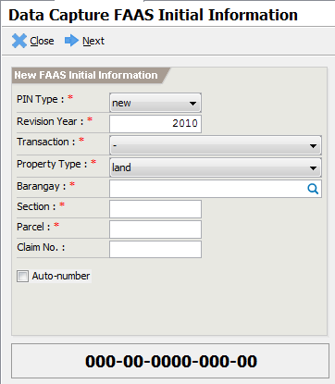
Figure 1. ETRACS Real Property Assessment Module: Land Data Capture and FAAS Encoding Interface (Source: Rameses Systems Inc., 2022).

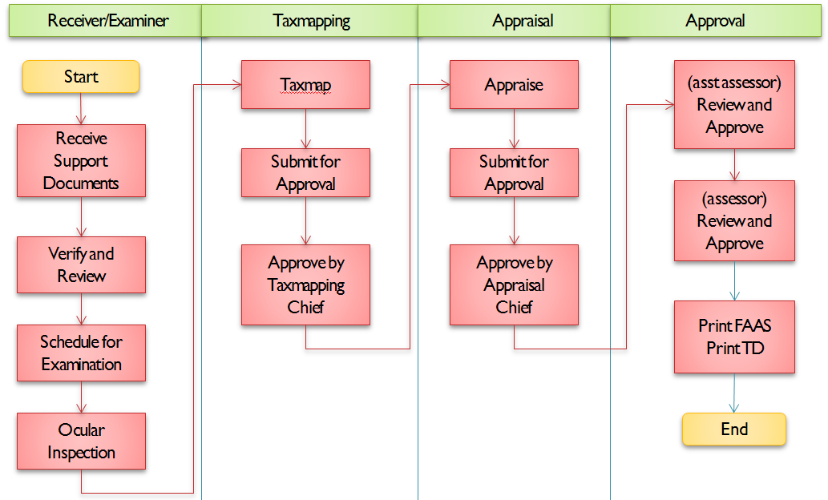
Figure 2. ETRACS Online Transaction Processing Panel: High-Density Transaction Grid and Approval Dialogs (Source: Rameses Systems Inc., 2022).

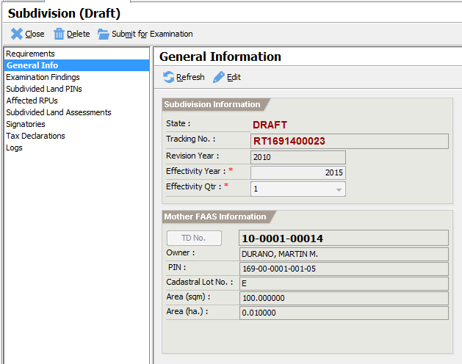
Figure 3. ETRACS Real Property Batch Processing and Revision Setting Interface (Source: Rameses Systems Inc., 2022).

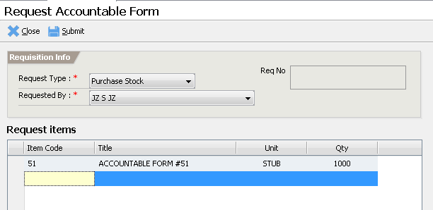
Figure 4. ETRACS Treasury Module: Accountable Form Management and Receipt Reconciliation (Source: Rameses Systems Inc., 2022).

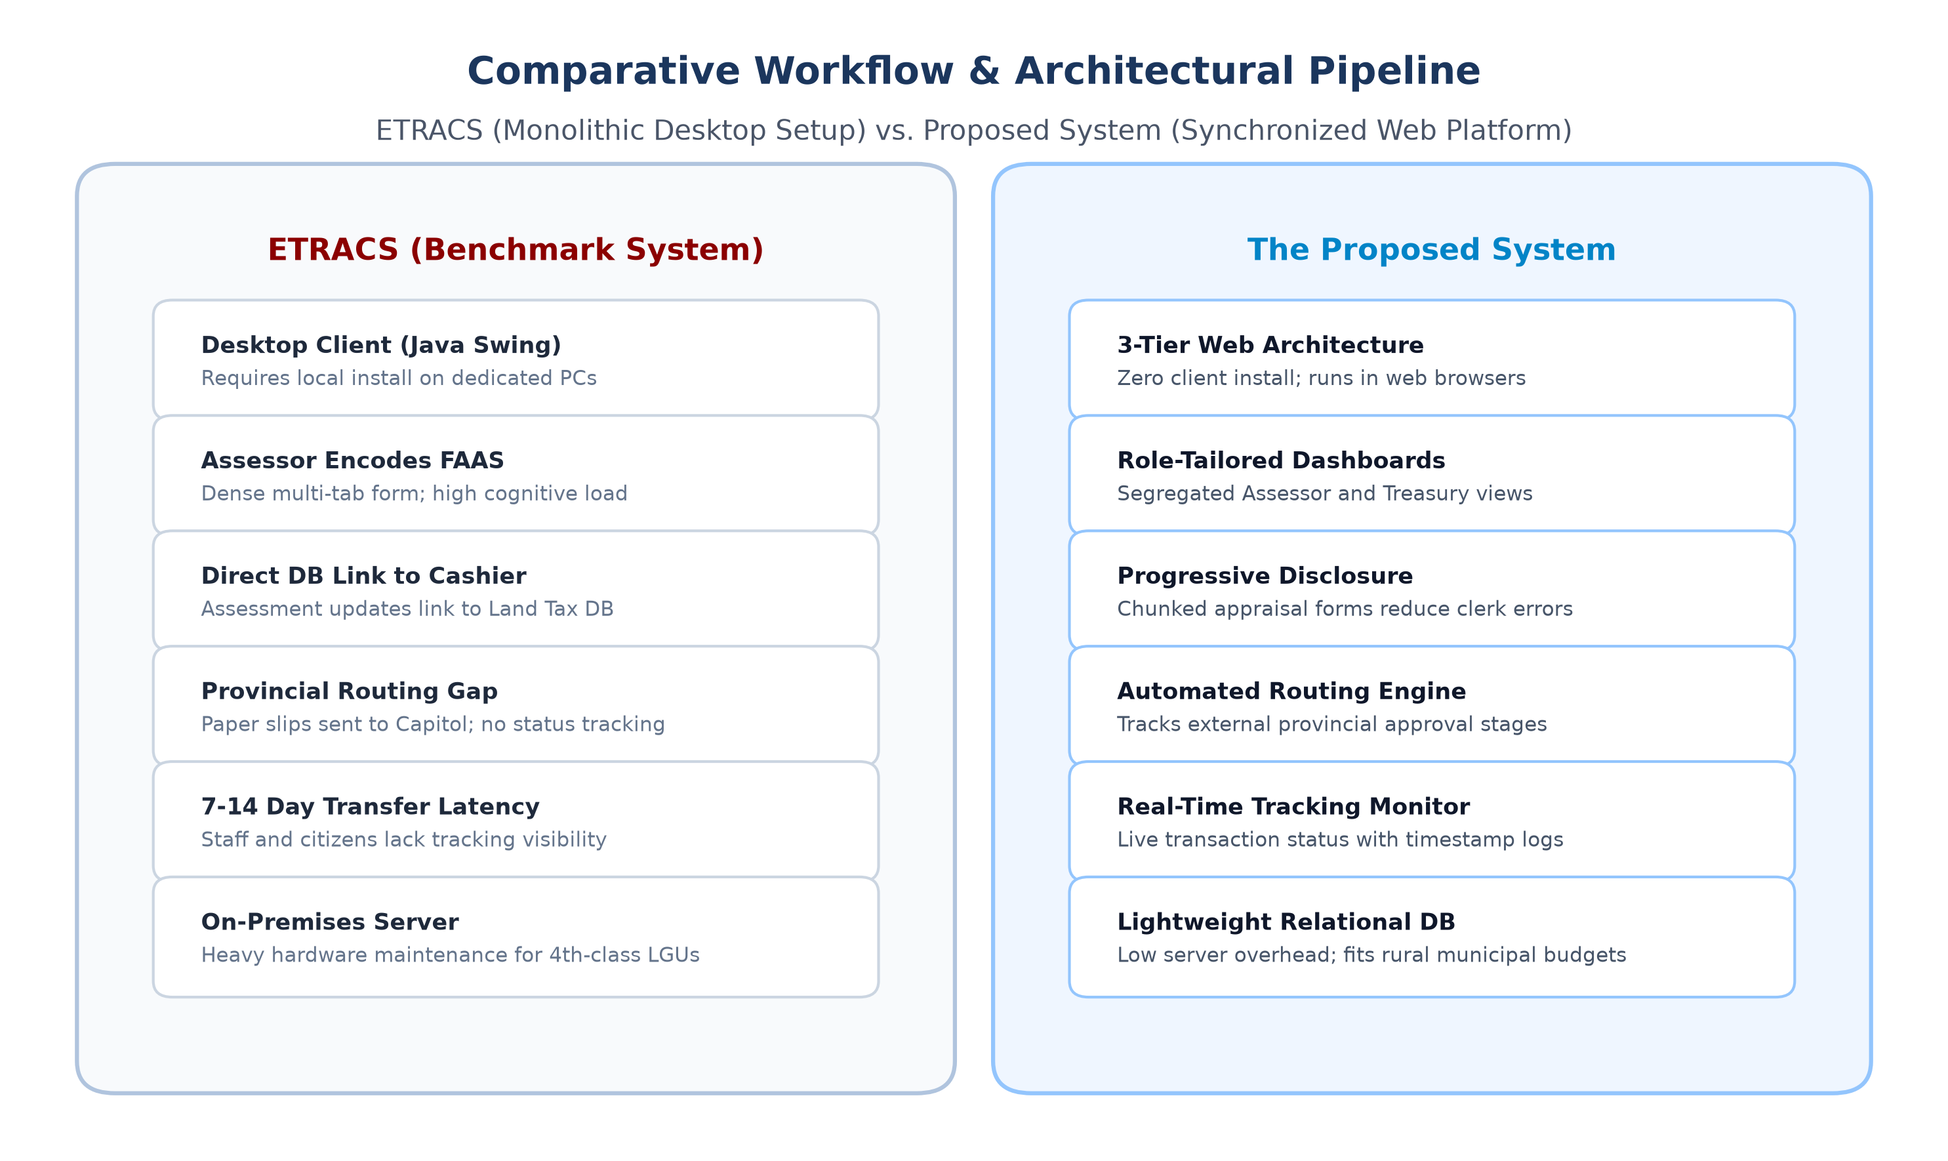
Figure 5. Comparative Workflow & Architectural Pipeline: ETRACS Monolithic Desktop Setup vs. Proposed System Synchronized Web Platform (Authors' Synthesis, 2026).
Appendix 2: Formal References (ACM Style)
Norberto Arrocena Chinilla and Glenne Berja Lagura. 2025. Enhanced tax revenue assessment and collection system through the lens of the municipal treasurers and assessors. International Journal for Multidisciplinary Research (IJFMR) 7, 4 (2025), 1–42. DOI: https://doi.org/10.36948/ijfmr.2025.v07i04.51726
Department of Information and Communications Technology. 2023. Philippine e-Government Interoperability Framework (PeGIF): Technical Data and Information Interoperability Standards for Local Government Units. DICT, Quezon City, Philippines.
International Organization for Standardization. 2006. ISO 9241-110:2006: Ergonomics of human-system interaction — Part 110: Dialogue principles. ISO, Geneva, Switzerland.
International Organization for Standardization. 2010. ISO 9241-210:2010: Ergonomics of human-system interaction — Part 210: Human-centred design for interactive systems. ISO, Geneva, Switzerland.
International Organization for Standardization. 2025. ISO 19152-4:2025: Geographic Information — Land Administration Domain Model (LADM) — Part 4: Valuation Information. ISO, Geneva, Switzerland.
Rameses Systems Inc. 2022. Enhanced Tax Revenue and Collection System (ETRACS): Real Property Assessment and Tax Administration Module. Rameses Systems Inc., Cebu City, Philippines. Retrieved October 10, 2026 from http://etracs.org and https://ramesesinc.github.io/documentation/
Republic of the Philippines. 1991. Republic Act No. 7160: An Act Providing for a Local Government Code of 1991. Official Gazette of the Republic of the Philippines, Manila.
Republic of the Philippines. 2012. Republic Act No. 10173: Data Privacy Act of 2012. Official Gazette of the Republic of the Philippines, Manila.
Republic of the Philippines. 2024. Republic Act No. 12001: Real Property Valuation and Assessment Reform Act (RPVARA). Official Gazette of the Republic of the Philippines, Manila.

